WattWizards – Financial Model Plan

**Credits: Mini-Shark Tank Egypt – IEEE YESIST12 - ISEF**

@XOperations - 2025

|  |  |
| --- | --- |
| **Title** | **WattWizards – Financial & Business Plan** |
| **Designed for** | **Electrical Engineers, Technicians, Universities, and Industrial Companies** |
| **Designed by** | **WattWizards** |
| **Date** | **4/11/2025** |
| **Version** | **Beta** |

**1. Executive Summary**

**WattWizards** is a scalable SaaS platform for electrical circuit analysis and computation targeting engineers, technicians, and educational institutions. The vision is to digitize and automate manual calculations in a sector ripe for disruption, with a hybrid model (freemium + subscription) supported by B2B licensing, and future mobile deployment.

**2. Initial Problem Cases (Real-World in Egypt)**

**Case 1: Manual Errors in Industrial Zones:** In regions like Borg El Arab, technicians still rely on manual calculations, leading to critical errors in load handling and equipment failures.

**Case 2: Lack of Practical Tools in Technical Education:** Students at vocational institutes (e.g., Don Bosco, Military Technical College) lack access to hands-on tools for real-world electrical circuit analysis.

**Case 3: SME Cost Constraints:** Small factories and workshops can't afford to hire professional electrical engineers. WattWizards offers a cost-effective alternative that enhances safety and accuracy.

**3. Revenue Model:**

* **Individual Subscriptions:** 5-10$/month
* **B2B Licensing:** For factories, and industrial firms
* **Institutional Packages:** For universities, schools and training centers
* **Mobile App Monetization (future):** Paid calculators, premium tools
* **Projected Total Revenue (Year 1):** ➡️ Undefined Yet

**4. Startup Costs (Year 1 - Setup & Launch Phase)**

**Full Stack Web App Hosting Cost Structure (GoDaddy - 2025)**

|  |  |  |
| --- | --- | --- |
| **Item** | **Description** | **Cost (Dollars)** |
| **Domain Name** | Wattwizards.org domain from GoDaddy | ~15-20 |
| **Hosting Plan** | Hostinger Deluxe Hosting  ✔ PHP, Node.js, MySQL, SSH | ~10-15 |
| **SSL Certificate** | Free with most business/shared plans (GoDaddy) | 0 |
| **Deployment Tools** | Git, FTP, cPanel/SSH (included in hosting plans) | 0 |
| **Custom Email** | contact@wattwizards.com via Zoho Mail (Free plan) or GoDaddy email add-on | ~1.5-2 |
| **Total** | Complete Professional Setup & Deployment Cost | ~26.5-37 |

**5. Old Version BMC**

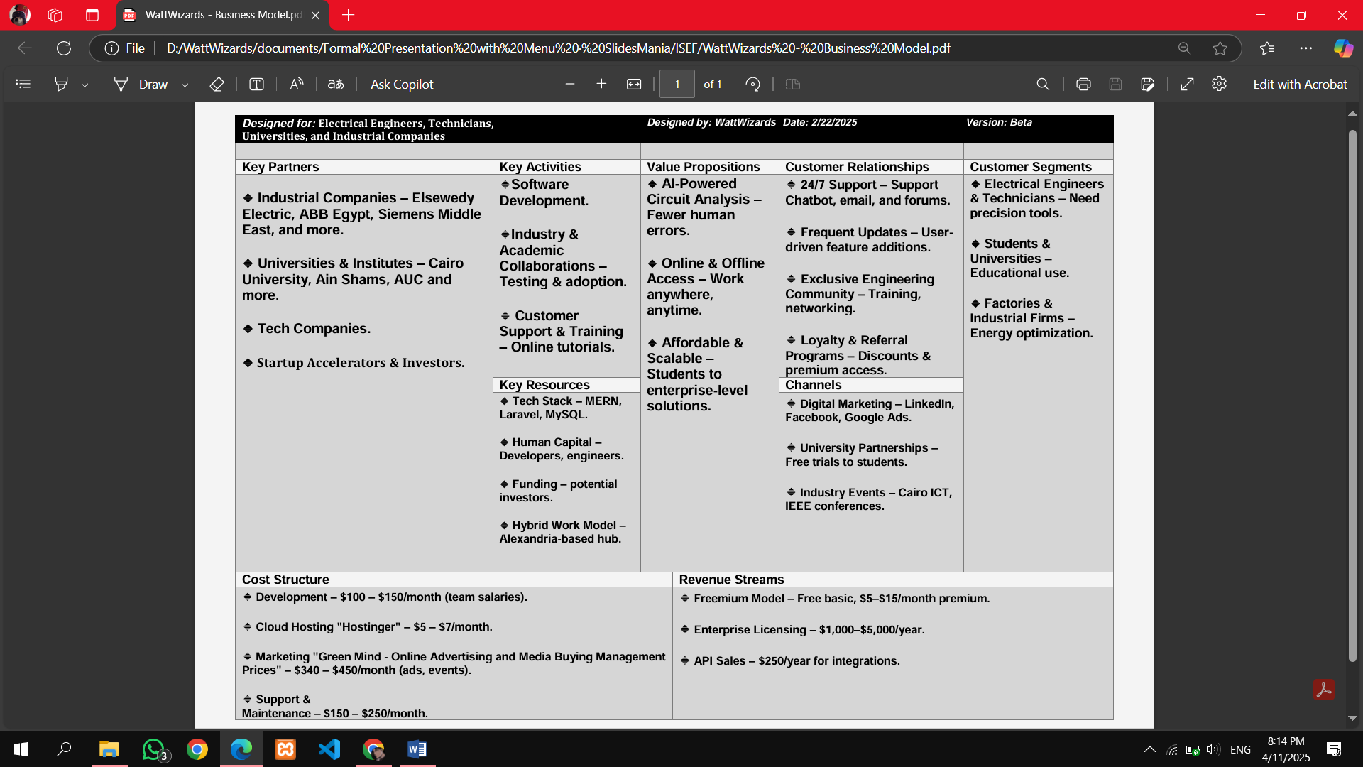

**6. Competitive Advantage in Egypt**

* AI-Powered Error Detection (future planned)
* Cross-Platform Compatibility (web + mobile roadmap)
* Project & Inventory Management Modules
* Offline & Online Workspaces